**Project Design Phase I**

This is a textbox...

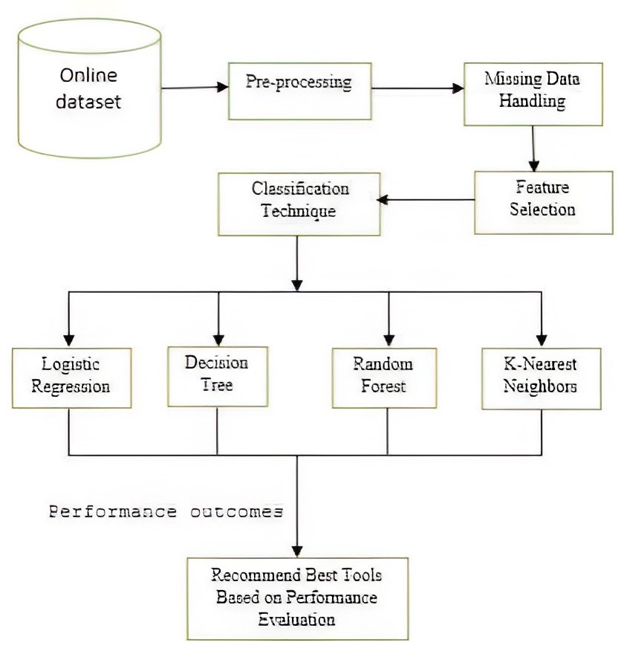**Solution Architecture**

|  |  |
| --- | --- |
| **Date** | 01 October 2022 |
| **Team ID** | PNT2022TMID23120 |
| **Project name** | Early Detection of Chronic Kidney Disease |
| **Maximum marks** | 2 Marks |

**Data Pre-Processing Stage**

**Online Dataset**

Pre- Processing

**Missing Data Handling**

Classification Technique

Feature Selection

**Model Buliding & Testing Stage**

Logitic Regression

Decision Tree

Random Forest

K- Nearest Neighbors

**Performance Outcomes**

**Model Testing &**

**Performance Evaluation**